BRACT’s
Vishwakarma Institute of Technology, Pune
Practical Implementation Sheet
Department: CSE-AI Semester: 5 Academic Year: 2026-27
Division: E Batch: 1 Practical No: 2
Roll no: 42 PRN No: 12414728 Name of Student: Saachi Laturiya
Subject Name : Deep Learning

Problem Statement : Design and implement a Multilayer Perceptron (MLP) for classification of the Iris or Wine dataset, and evaluate its performance using accuracy and a confusion matrix.
Algorithm :
- Import the required Python libraries for data handling, visualization, preprocessing, and machine learning.
- Load the Iris dataset from the Scikit-learn library.
- Separate the dataset into input features (X) and target labels (y).
- Create a DataFrame for visualization purposes.
- Visualize the relationship between different features using a pair plot.
- Display the correlation between features using a heatmap.
- Split the dataset into training and testing sets.
- Standardize the feature values using StandardScaler.
- Create an MLP classifier with two hidden layers using the ReLU activation function and Adam optimizer.
- Train the MLP classifier using the training dataset.
- Predict the class labels for the testing dataset.
- Calculate the classification accuracy.
- Display the confusion matrix and classification report.
- Visualize the confusion matrix using a heatmap.
- Compare the actual and predicted class labels using a line plot.
Code :
- Import the required libraries for data manipulation, visualization, preprocessing, and MLP classification.
- Load the Iris dataset and separate it into input features and target labels.
- Convert the dataset into a DataFrame and assign species names for visualization.
- Visualize the relationship between different Iris features using a pair plot.
- Display the correlation among all input features using a heatmap.
- Split the dataset into training and testing sets.
- Standardize the training and testing data using StandardScaler.
- Create an MLP classifier with two hidden layers using the ReLU activation function and Adam optimizer.
- Train the classifier using the training dataset.
- Predict the class labels for the testing dataset.
- Calculate the classification accuracy of the model.
- Display the confusion matrix and classification report.
- Visualize the confusion matrix using a heatmap.
- Compare the actual and predicted class labels using a line plot.

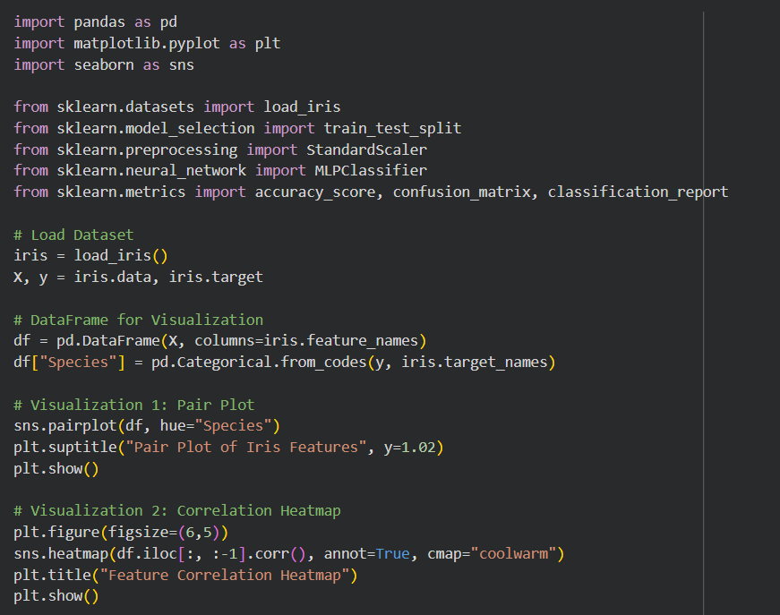
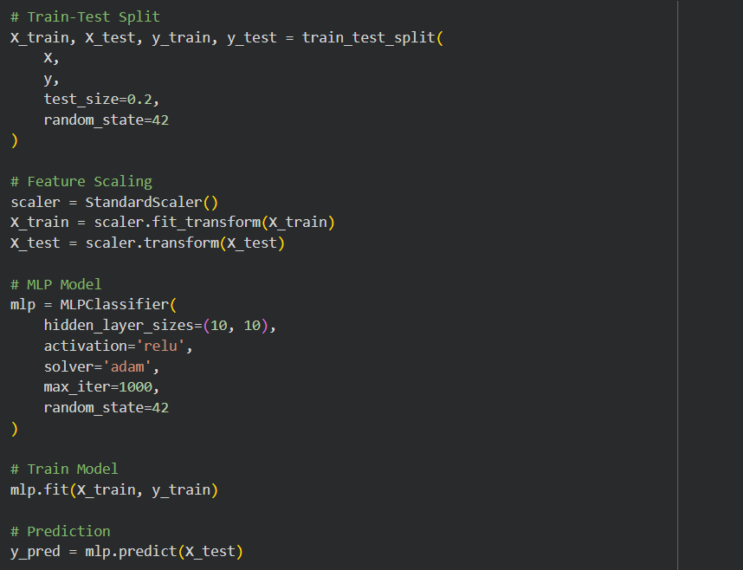
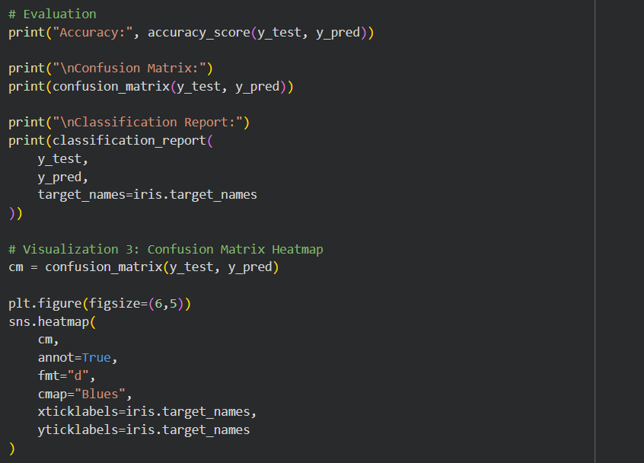
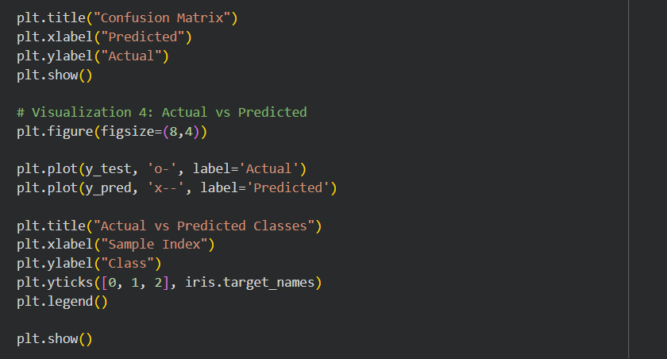

Output :
Figure 1: Pair plot showing the relationship among different Iris flower features.
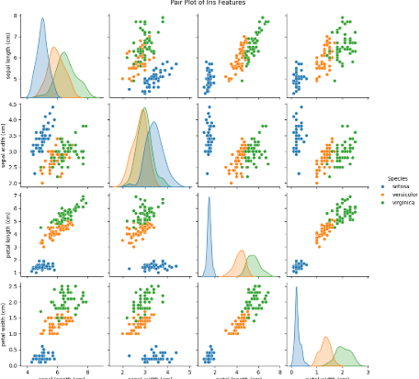
Figure 2: Correlation heatmap illustrating the relationship between the input features of the Iris dataset.
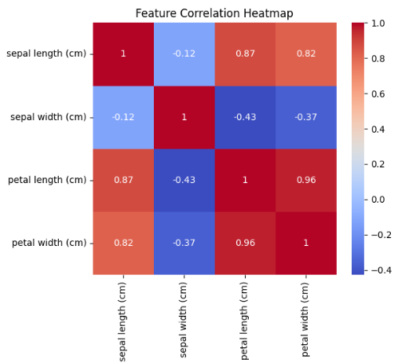
Figure 3: Performance metrics obtained after testing the MLP classifier.
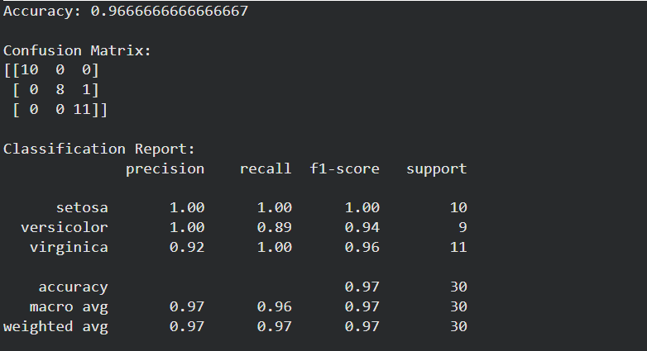
Figure 4: Confusion matrix heatmap representing the classification performance of the MLP classifier.
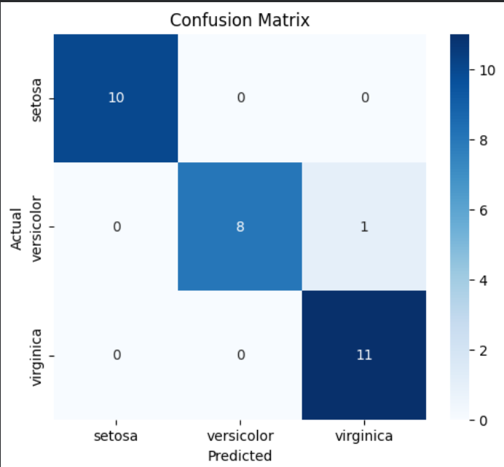
Figure 5: Comparison of actual and predicted class labels obtained from the MLP classifier.
